**Definition: Create the design using Figma Design Tool Color Styles.**

**Solution:**

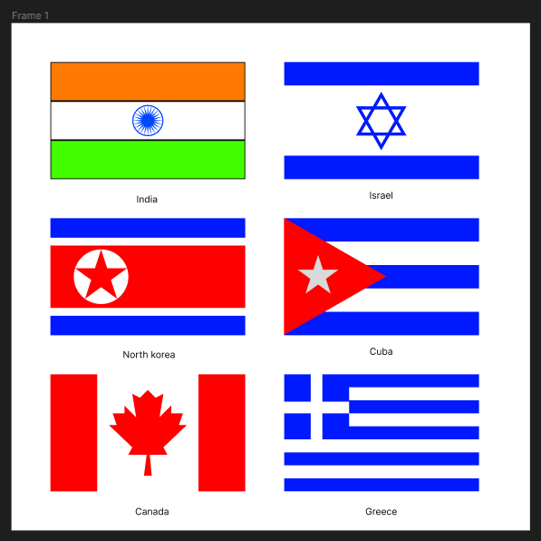

**Steps:**

* First Open Figma in browser mode.
* Then create the new document **File à New Figma Design.**
* Now add one frame using the Frame tool and select a frame of width=”**734px”** and height=”**538px”** on your canvas.
* **For the India’s flag:**
* Take the Rectangle tool and draw a rectangle of width=**”250px”** and height=**”50px”**. Fill with color **“#FF7A00”**. This Rectangle indicates the first orange color of India’s flag.
* Take the Rectangle tool and draw a rectangle of width=**”250px”** and height=**”50px”**. Fill with color **“#FFFFFF”**. This Rectangle indicates the second white color of India’s flag.
* Take the Ellipse tool and draw a circle in the center of white color of width and height=**”40px”**.
* Inside this circle draw a star of width and height=**”40px”** and Fill with color **“#0047FF”** and give count=**"24 ".**
* These circle and stars indicate the Ashok chakra of India’s flag.
* Take the Rectangle tool and draw a rectangle of width=**”250px”** and height=**”50px”**. Fill with color **“#42FF00”**. This Rectangle indicates the first green color of India’s flag.
* **For the Canada’s flag:**
* Take a rectangle tool and draw a rectangle of width=**”130px”** and height=**”150px”** and fill with color **“#FFFFFF”**. This rectangle indicates the white color of Canada’s flag.
* Left and right side of this rectangle draw a rectangle of width=**”60px”** and height=**”150px”** and fill with color **“#FF0000”**. This rectangle indicates the red color’s rectangle of Canada’s flag.
* Take rectangle of width=**”100px”** and height=**”110px”,** Fill with color **“#FF0000”**. Then make shape of the red maple leaf of that rectangle.
* **For the North Korea's flag:**
* Take a rectangle tool and draw a rectangle of width=**”250px”** and height=**”80px”** and fill with color **“#FF0000”**. This rectangle indicates the red color of North Korea's flag.
* Up and Downside of this rectangle draw a rectangle of width=**”250px”** and height=**”10px”** and fill with color **“#FFFFFF”**. This rectangle indicates the white color’s rectangle of North Korea's flag.
* Take another rectangle beside white rectangles of width=**”250px”** and height=**”25px”** and fill with color **“#001AFF”**. This rectangle indicates the blue color’s rectangle of North Korea's flag.
* Now draw Ellipse of width=”**70px**” and height=”**70px**” than fill with color “**#FFFFFF**”. This ellipse indicates the white color’s circle of North Korea's flag.
* Inside of Ellipse draw Star of width and height=**”70px”** and Fill with color **“#FF0000”** and give count=**”5”.**
* **For the Israel’s flag:**
* Take a rectangle tool and draw a rectangle of width=**”250px”** and height=**”90px”** and fill with color **“#FFFFFF”**. This rectangle indicates the white color of Israel’s flag.
* Left and right side of this rectangle draw a rectangle of width=**”250px”** and height=**”30px”** and fill with color **“#001AFF”**. This rectangle indicates the blue color’s rectangle of Israel’s flag.
* Inside the white rectangle draw two Polygon of width and height=**”75px”** and Fill with color **“#001AFF”** and rotate one polygon to “**180**°”**.**
* **For the Cuba’s flag:**
* Take a rectangle tool and draw 5 rectangles of width=**”250px”** and height=**”30px”** and fill with color **“#001AFF**” and **“#FFFFFF”.** This rectangle indicates the blue and white color of Cuba’s flag.
* Now take polygon tool and draw a polygon of width=**”173px”** and height=**”175px”** and fill with color **“#FF0000”** rotate it to “**-90°”.** Place this polygon over previse 5 rectangles.
* Inside the polygon draw star of width and height=**”55px”** and Fill with color **“#FFFFFF”** and give count=**”5”.**
* **For the Greece’s flag:**
* Take a rectangle tool and draw 5 rectangles of width=**”250px”** and height=**”17px”** and fill with color **“#001AFF**” and **“#FFFFFF”.** This rectangle indicates the blue and white colored pattern of Greece’s flag.
* On that pattern draw rectangles of width=**”84px”** and height=**”84px”** and fill with color **“#001AFF**”. This rectangle indicates the blue colored square on Greece’s flag.
* Now inside of that square draw two rectangle of width=**”15px”** and height=**”84px”** and fill with color **“#FFFFFF**”. Then rotate one rectangle to “**-90°”.** This rectangle indicates the white colored plus sign of Greece’s flag.
* Now, Go to the **Export** button in the property panel. And **Export** it with .**JPG/.PNG** format.